**1.Counting Elements**

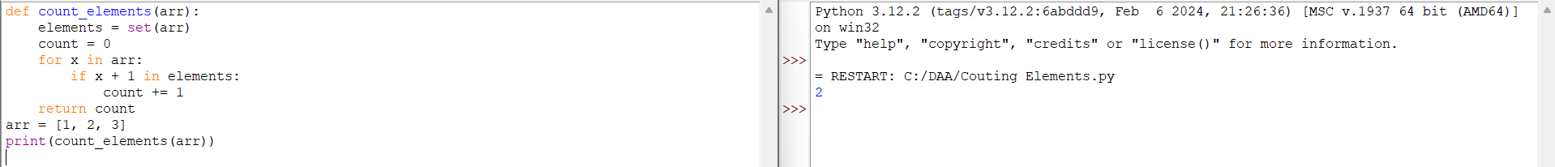

**2.Perform String Shifts**

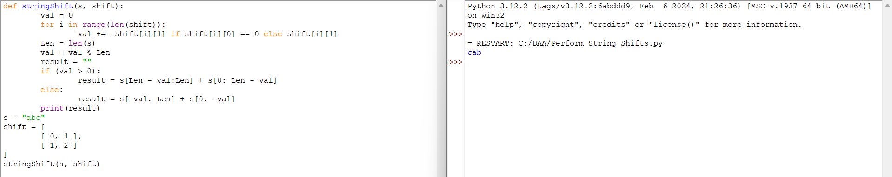

**3.Leftmost Column With at Least a One**

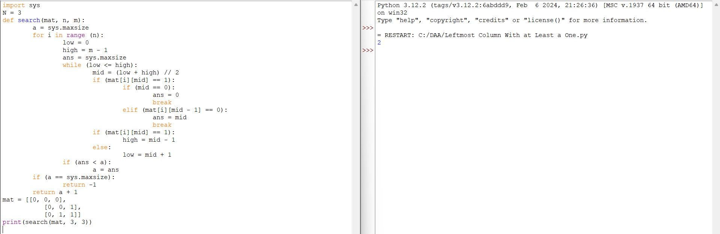

**4.First Unique Number**

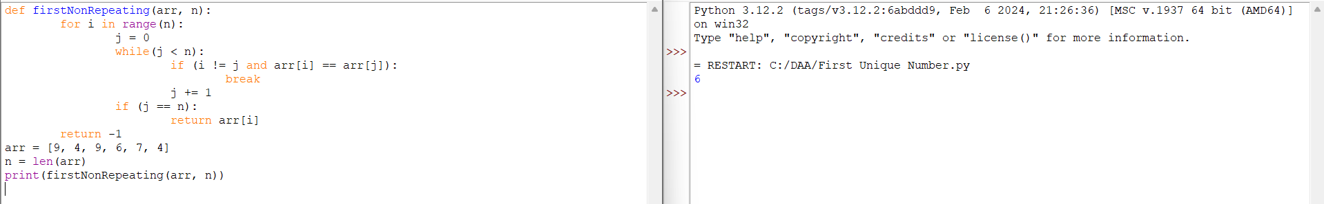

**5. Check If a String Is a Valid Sequence from Root to Leaves Path in a Binary Tree Given a binary tree where each path going from the root to any leaf form a valid sequence, check if a given string is a valid sequence in such binary tree.**

**We get the given string from the concatenation of an array of integers arr and the concatenation of all values of the nodes along a path results in a sequence in the given binary tree.**

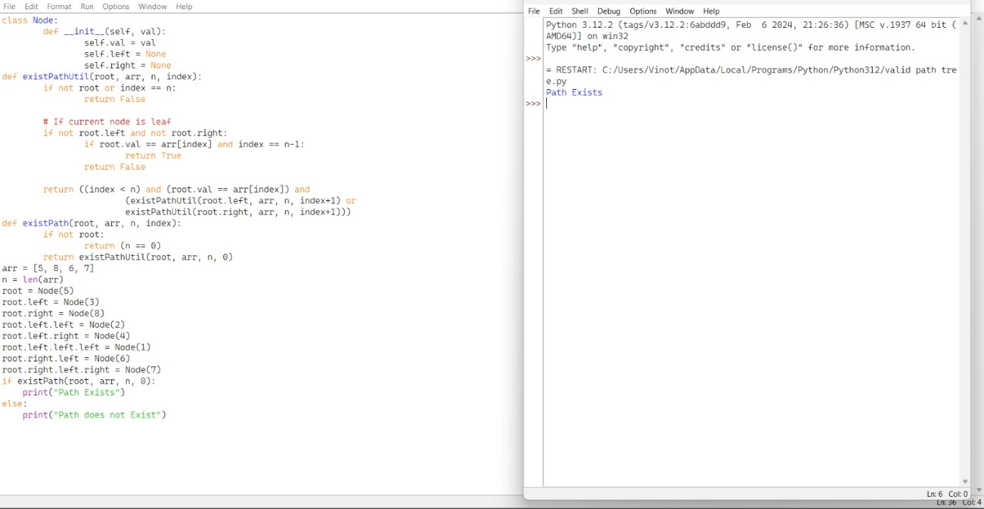

**6.Kids With the Greatest Number of Candies**

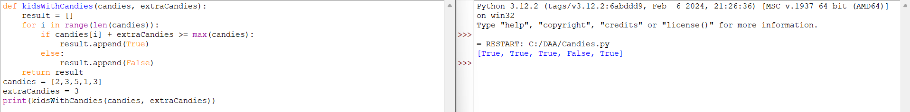

**7.Max Difference You Can Get from Changing an Integer**

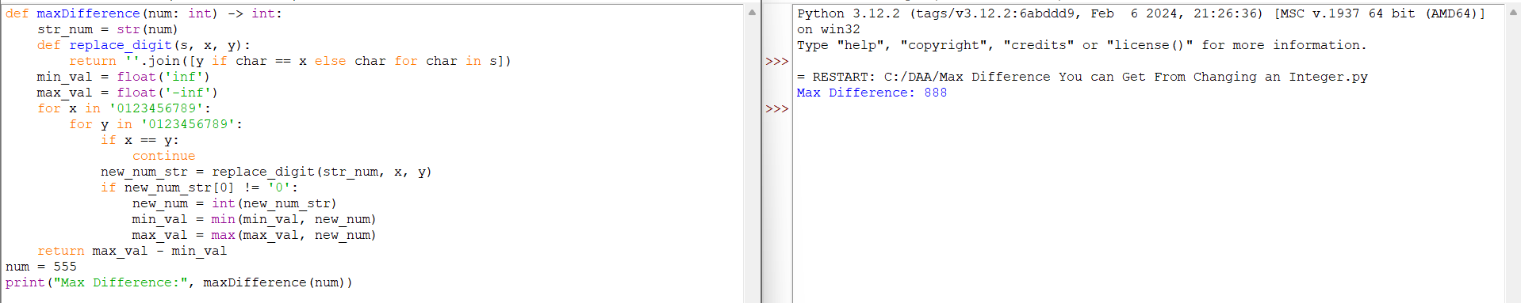

**8.Check If a string Can Break Another String**

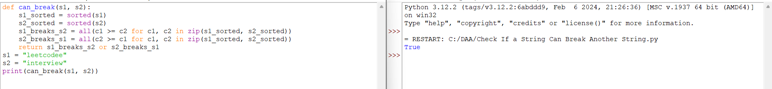

**9.Number of Ways to Wear Different Hats To Each Other**

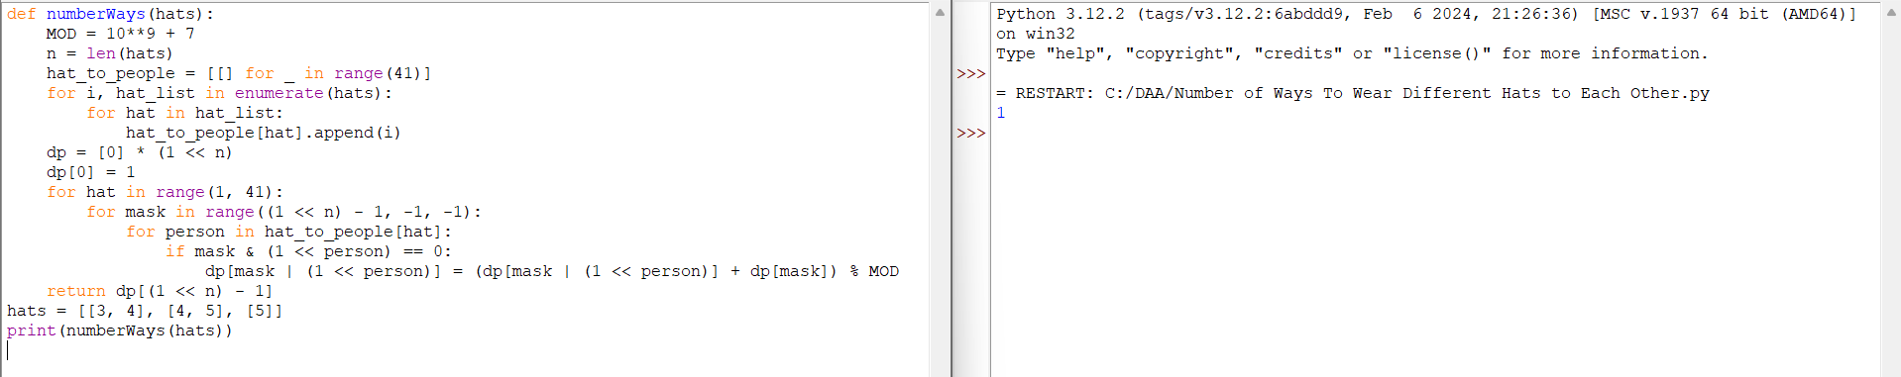

**10.Next Permutation**

